Les verbes irréguliers au Passé Composé

Verbe Faites une phrase au présent et au passé composé – Write a sentence with the given verbs au présent / au PC
être ____________________________________________________________________________________________
avoir ____________________________________________________________________________________________
faire ____________________________________________________________________________________________
vouloir ____________________________________________________________________________________________
prendre ____________________________________________________________________________________________
apprendre ____________________________________________________________________________________________
mettre ____________________________________________________________________________________________
devoir ____________________________________________________________________________________________
recevoir ____________________________________________________________________________________________
voir ____________________________________________________________________________________________
dire ____________________________________________________________________________________________
dormir ____________________________________________________________________________________________
aller ____________________________________________________________________________________________
tomber ____________________________________________________________________________________________
se laver ____________________________________________________________________________________________
se mettre _____________________________________________________________________________________________
Lecture A.
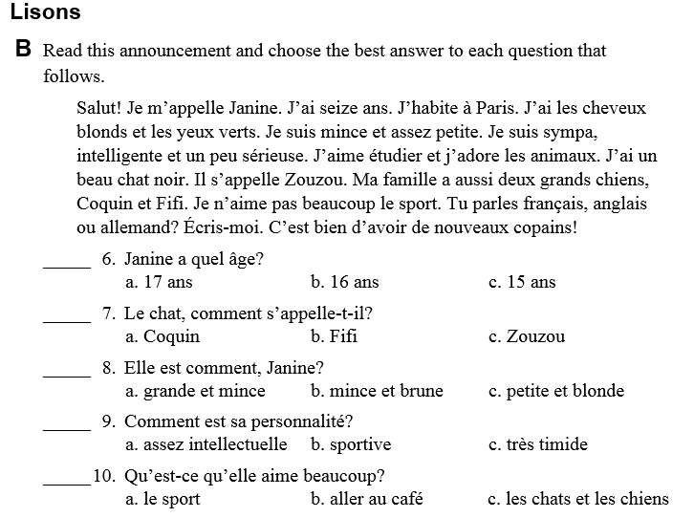

Réponses :

Ecriture A :
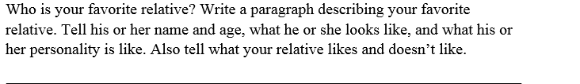
_____________________________________________________________________________________________________
_____________________________________________________________________________________________________
_____________________________________________________________________________________________________
_____________________________________________________________________________________________________
_____________________________________________________________________________________________________
_____________________________________________________________________________________________________

Lecture B :
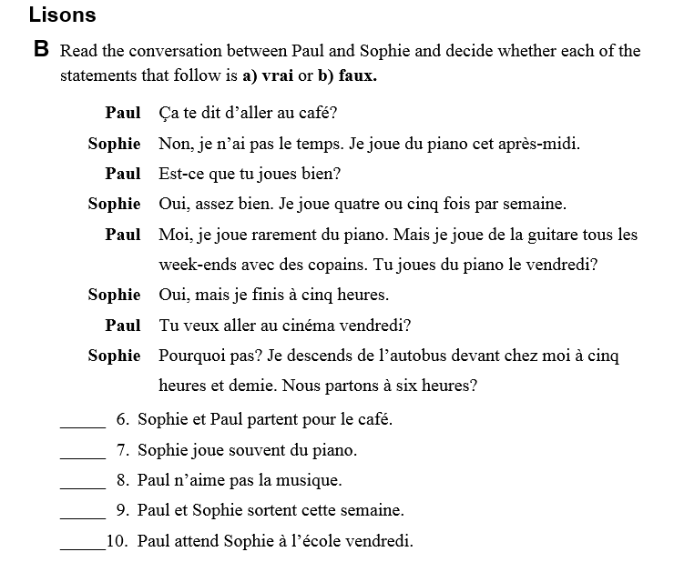

Réponses :

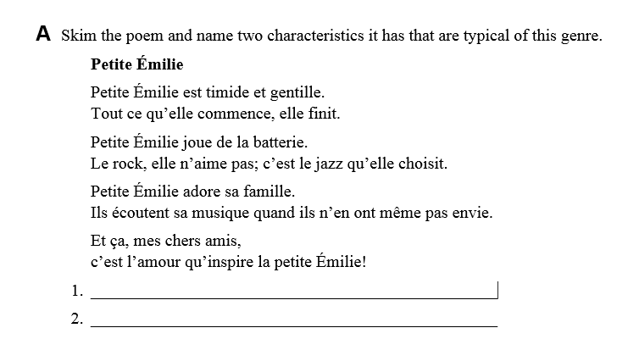

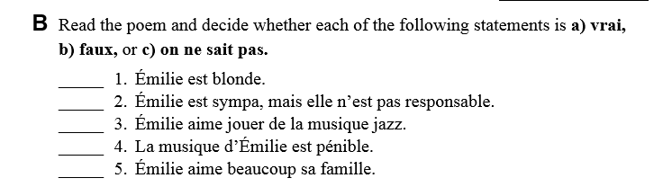
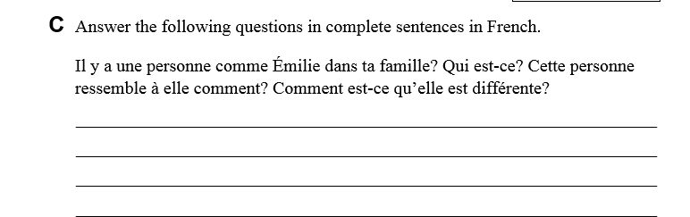

Ecriture :
« What did you do this summer ? » Write a paragrah using at least 10 differents verbs au passé composé. Make sure to use transitional words to connect your ideas.
_____________________________________________________________________________________________________
_____________________________________________________________________________________________________
_____________________________________________________________________________________________________
_____________________________________________________________________________________________________
_____________________________________________________________________________________________________
_____________________________________________________________________________________________________

Rubric /20pts:
- Content : ____ 10 verbs : _____
- Au passé composé : ______ Transition : _____

