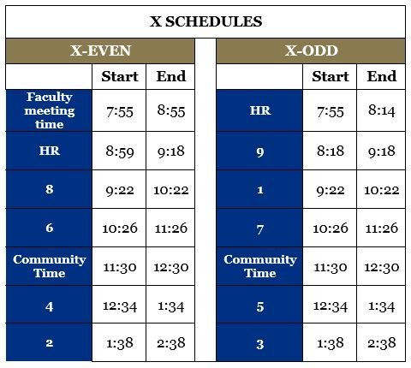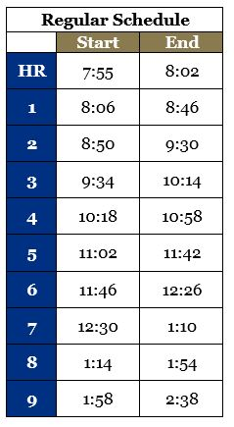

**Homeroom** will now meet every day of the letter day cycle. All students are required to attend homeroom, every day. Every student also has a **lunch** period, either during 4th, 5th, 6th, or 7th period.

Similar to this past year, students have the option of coming to school later on **X-Even** days. **Community Time** is a new feature of the school schedule, and will be time dedicated to meeting with clubs/activities, exploring new extra-curricular opportunities, meeting with teachers for extra help and/or eating lunch.

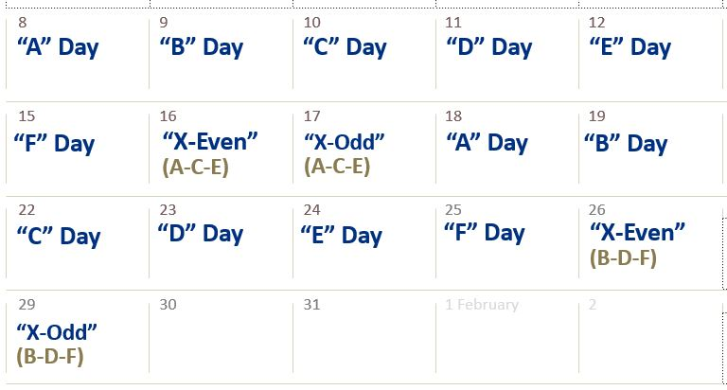

**X-day schedules** will be run at the end of every 6-day cycle (after letter days A-F) **see example above**. The classes that will meet on X-Even and X-Odd days are now listed on a student’s schedule. Generally, the X-Day pairs will rotate between dominant class periods on **A-C-E or B-D-F** letter days.